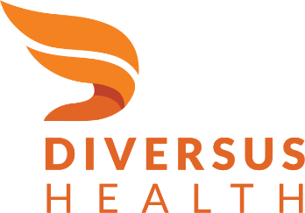

Recovery Residences
  - Request for Application (RFA)
Issued: 02/08/2022

875 W. Moreno Ave., Colorado Springs, CO 80905

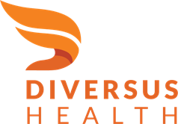

DIVERSUS HEALTH NETWORK
Recovery Residences – Request for Application

summary
The purpose of this funding is to support rental costs for people in recovery residences who cannot afford initial rent. These funds are to support Colorado residents who are in recovery from a stimulant or opioid use disorder who temporarily are unable to afford the rent costs associated with living in a recovery residence located in Colorado. While most people can pay for their rent at such recovery residences, this program aims to support those for whom rent is a temporary barrier to entry.

With this collaboration, Diversus Health aims to serve 318 individuals with 476 months of service. While the priority for this funding is to provide rental support for individuals with financial need, contractors may use up to 10% of available funds to support recovery residence capacity expansion within the contractor’s respective region(s).

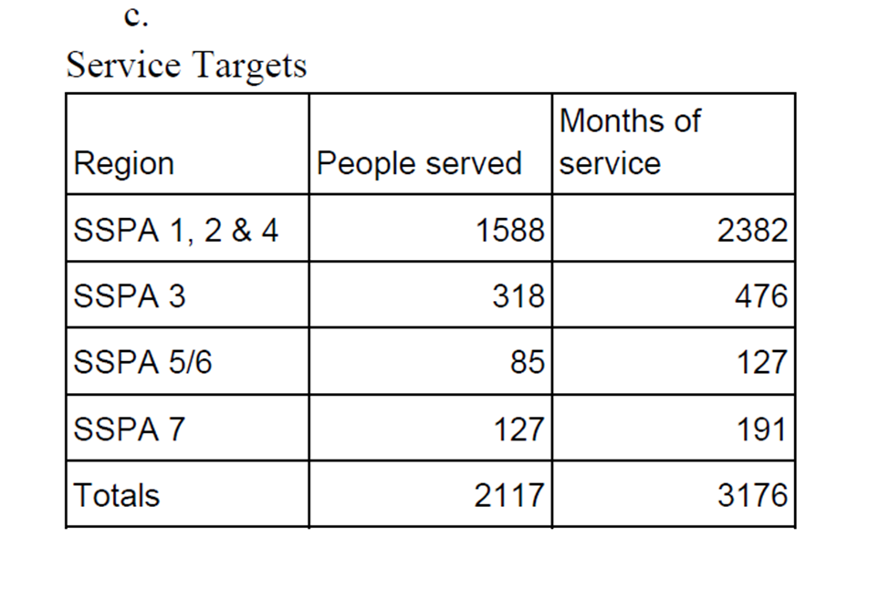

Acronyms & Definitions
RFA – Request for Application

Application – A complete and appropriately submitted response to the RFA

Standard – A rule or principle considered by an authority or by general consent as a basis of comparison or judgement; an approved model.

Peer – Someone who shares the experience of living with a psychiatric disorder and/or addiction. A Peer may have the experience either directly or as family members or significant others.

Peer Support Services – A range of activities and interactions between people who share similar experiences of being diagnosed with mental health conditions, substance use disorders, or both.

Recovery Supports – An array of services intended to manage mental health symptoms; increase housing to support recovery; reduce barriers to employment, education, and other life goals; and secure necessary social supports in their chosen community.

Recovery Residency - Any premises, place, facility, or building that provides housing accommodations for individuals with a primary diagnosis of a substance use disorder that:
- is free from alcohol and non-prescribed or illicit drugs;
- promotes independent living and life skill development; and
- provides structured activities and recovery support services that are primarily intended to promote recovery from substance use disorders.

Workforce Development – A combination of social services, community supports, job training, and education that positions an individual for success in the workforce.

Treatment Providers – Providers with expertise in substance use disorder care can ensure recovery-focused attention to prevention, assessment, and treatment. These providers are licensed agencies under these rules by the Department of Human Services to provide substance use disorder treatment.

Target Population – Coloradans living with Substance Use Disorder and/or co-occurring conditions will be supported. Services are to ameliorate the increases in Co-Occurring and Substance Use Disorder needs related to the COVID-19 pandemic but are not limited to only pandemic-affected persons.

Pro-social Activities – Activities that give people in recovery access to a social group with shared goals and values. This experience contributes to a sense of belonging, fosters a sense of shared purpose, and ultimately, increases self-belief, self-confidence, and self-esteem

Proposal Format
Provider proposals must comprehensively address these items:
- Program or service description
- Needs justification
- Implementation timeline and requested term of service offering
- Location(s) that the services will be offered
- Continuum included in the service offering
- Sustainability strategy
- Budget
- Licensing/certification
Diversus Health Network encourages provider agencies to think creatively with their requests. Examples of applications which could receive funding are those that incorporate:
- Evidence-based Curriculums or Programs
- Workforce Development
- Services Capacity ExpansionSUD-related Transportation
- Pro-social activities
Special consideration will be given to projects which improve or expand access to services and those which benefit adolescents and priority populations (pregnant women, women with dependent children, and IV-drug users). Proposers should be specific when speaking to these criteria.

Project standards/requirements
In order to receive funding under this project, recovery residence programs must be either a chartered Oxford House or Colorado Association of Recovery Residences (CARR) certified.

Diversus Health Network intends to support rent expenses at programs that also meet the National Alliance for Recovery Residences (NARR) definitions of recovery residences, known as NARR’s 4 Levels of Support, in particular, those within the categories of Level 1 and Level 2:
- Peer-Run
  - Most appropriate level for individuals who have established adult living skills, are able to self-regulate, and are committed to their recoveries
- Monitored
  - Most appropriate level for individuals with some intrinsic motivation who would benefit from a nominal level of structure and support
- Supervised
  - Most appropriate level for individuals who need higher degrees of structure and support, perhaps coming out of a stabilizing residential treatment center
- Service Provider
  - Most appropriate level for individuals new to the recovery process and/or needing life skill development

NARR’s Recovery Residence 4 Levels of Support
 | Peer-Run | Monitored | Supervised | Service Provider
Standards Criteria: Administration | Democratically run  Manual or P&P | House manager or senior resident  Policy and Procedures | Organizational hierarchy  Administrative oversight for service providers  Policy and Procedures  Licensing varies from state to state | Overseen organizational hierarchy  Clinical and administrative supervision  Policy and Procedures  Licensing varies from state to state
Standards Criteria: Services | Drug screening  House Meetings  Self-help meetings encouraged | House rules provide structure  Peer run groups  Drug Screening  House meetings  Involvement in self-help and/or treatment services | Life skill development emphasis  Clinical services utilized in outside community  Service hours provided in house | Clinical services and programming are provided in house  Life skill development
Standards Criteria: Residence | Generally single-family residences | Primarily single-family residences  Possibly apartments or other dwelling types | Varies – all types of residential settings | All types – often a step-down phase within care continuum of a treatment center  May be a more institutional in environment
Standards Criteria: Staff | No paid positions within the residence  Perhaps an overseeing officer | At least 1 compensated position | Facility manager  Certified staff or case managers | Credentialed staff

In addition, Diversus Health Network supports NARR’s National Standard – the first national quality standard for recover residence programs - and intends to hold all applicant providers to it as well. The table below outlines its domains and their associated principles and qualities in further detail.

2015 NARR National Standard
Domain | Principle | Quality Standard
Administrative and Operational | Operate with integrity  Uphold resident rights  Are recovery-oriented  Are peer staff and governed | Are guided by a mission and vision
 |  | Adheres to legal and ethical codes
 |  | Are financially honest and forthright
 |  | Collect data for continuous quality improvement
 |  | Operate with prudence
 |  | Communicate rights and requirements before agreements are signed
 |  | Promote self and peer advocacy
 |  | Support housing choice
 |  | Protect privacy
 |  | View recovery as a person-driven, holistic and lifelong process
 |  | Are culturally responsive, congruent and/or competent
 |  | Are peer staffed and governed
 |  | Involve peers in governance in meaningful ways
 |  | Use peer staff and resident leaders in meaningful ways
 |  | Maintain resident and staff leadership based on recovery principles
 |  | Create and sustain an atmosphere of recovery support
 |  | Ensure staff are appropriately trained and credentialed
 |  | Provide support staff supervision
Recovery Support | Promote health  Provide a home  Inspire purpose  Cultivate community | Encourage residents to own their own recovery
 |  | Inform residents about community-based supports
 |  | Offer recovery support services in informal settings
 |  | Offer recovery support services in formal settings
 |  | Offer life skills development in formal settings
 |  | Offer life skills development in informal settings
 |  | Provide a physically and emotionally safe, secure and respectful environment
 |  | Are alcohol and drug-free environments
 |  | Offer clinical services in accordance with State law
 |  | Are cultivated through structure and accountability
 |  | Promote meaningful daily activities
 |  | Create a “functionally equivalent family”
 |  | Foster ethical peer-based mutually supportive relationships between residents and/or staff
 |  | Connect residents to the local recovery community
Property and Architecture | Promote recovery  Promote health and safety | Promote home safety
 |  | Create a home-like environment
 |  | Promote community
 |  | Have an emergency plan
Good Neighbor | Are good neighbors | Are compatible with the neighborhood
 |  | Are responsive to neighbor complaints
 |  | Have courtesy rules

Program Outcomes
Selected provider agencies will be required to report the following participant data to Diversus Health Network on a determined basis.
- Total individuals served
- Percent of persons served who maintained recovery while rent support was provided
- Number of persons served who attained employment leading to an end in financial support for rent

location
The services outlined in this document should be administered in any or all the following Colorado Counties: Chaffee, Custer, El Paso, Fremont, Lake, Park, and Teller.

Non-discrimination
All providers of services shall not discriminate against any client based on color, race, gender, sexual orientation, age, religion, national origin, handicap, health status, or source of payment in provider services under this agreement.

Submission Deadline & Instructions
Organizations interested in offering theses services must submit their proposal by email to hndeliverables@diversushealth.org. The project narrative must be submitted in Microsoft Word format and limited to no more than five (5) pages. An associated budget must also be submitted and must use the State Office of Behavioral Health (OBH) capacity budget protocol worksheet in Microsoft Excel format.

Diversus Health Network will acknowledge receipt of each proposal. If no acknowledgement occurs, respondents to this Request for Application should resubmit their applications. The deadline for submission is no later than 02/16/2022 by 5:00 p.m.

Diversus Health Network will begin considering requests for funding through a formal scoring process. We will begin funding successful Applications as soon as possible.

Budget
Diversus Health Network recognizes that this funding is only a part of the support necessary to provide the services submitted in the Application. Additional funds may be needed, including Medicaid, other governmental sources, client fees, grants, local hospital support, and other sources. The OBH capacity protocol provides a mechanism to capture all funding sources relative to total expenses.

It is important to note that there are two general forms by which a service expansion can take place. Please note under this RFA all projects must result in an expansion of services.
- Increase of clients serviced: A program could be expanded to serve more clients, a new population of clients, or a new service area.
- Expansion program or facility: A new program could be established or expansion of an existing program. Effectively, these are one-time costs associated with the expansion. While capital expenses are included in the definition of expansion, they are not covered under this funding.

Term of agreement
Diversus Health Network seeks provider agencies who will offer or deploy the services outlined beginning as soon as possible, with optional renewals of the contract in subsequent years. This initial funding term will be through June 30, 2022, with possible renewals beyond this date based on available State and Federal funding sources.

Evaluation & Decision
Diversus Health Network will review all proposals upon receipt and provide responses. Failure to provide a complete set of information requested in this document may result in exclusion from consideration.

Diversus Health Network may seek clarifying information as necessary to make an informed decision either from the respondent provider or from other sources.

After selection of a provider or providers for these services, Diversus Health Network will notify remaining respondents of the decision.

