Building Substance Use Disorder Treatment Capacity in
Rural and Frontier Colorado
GRANT APPLICATION PROCESS
Round 5 - July 1, 2024 - June 30, 2026

Building Substance Use Disorder Treatment Capacity in Rural and Frontier Colorado – Grant Program Application
(House Bill 19-1287)
1. Overview and Timeline
1.1 About House Bill 19-1287

This document will provide guidance to the Managed Service Organizations (MSO) on the grant application and contracting process supported by funds appropriated through House Bill 19-1287. These funds are intended to increase substance use disorder capacity and services in rural and frontier communities and may include capital investment.

Eligible applicants include local governments (including Indian tribal reservation), municipalities, counties, schools, law enforcement agencies, and primary care or substance use disorder treatment providers) within or outside of the managed service organization's network of providers, may be eligible to apply for this grant program to increase substance use disorder treatment services and capacity in rural or frontier counties.

1.2 Round 5, 19-1287 Procurement

The Managed Service Organization system is sunsetting on June 30, 2025. On that day, MSO operations will cease and all MSO functions will be replaced with Behavioral Health Administrative Service Organizations (BHASOs) on July 1, 2025. Diversus Health Network is authorized by the Behavioral Health Administration to make an award on the BHA’s behalf for a two-year project period. The first year will operate under a contract with Diversus Health Network, the MSO. The BHASO selected for Applicant’s region will be required to honor the second year of the project period. Applicant(s) will sign a new contract with the BHASO for year two services at the funding level indicated in its proposal.

1.3 Background and Goals

Overdose deaths in Colorado have nearly tripled since 1999, led by a fivefold increase in opioid related deaths, surpassing other causes such as traffic accidents and guns (Colorado Health Institute, Feb. 2018). Access to treatment, particularly medication assisted treatment (MAT), saves lives; yet barriers to access remain. According to the 2017 Colorado Health Access Survey, more than 67,000 Coloradans needed treatment for drug or alcohol use but did not receive it.

Colorado has expanded the substance use disorder treatment benefit under the State Medicaid plan, but gaps in services still exist, particularly in rural and frontier communities. Even though a service is covered, it does not mean there is adequate capacity, nor does it mean that all communities have the services that are needed.
In May 2019, Governor Jared Polis signed House Bill 19-1287 which created a grant program that appropriated funds to the Behavioral Health Administration (BHA) to increase substance use disorder capacity and services in rural and frontier communities through the MSO. Each MSO area that consists of at least fifty percent rural or frontier counties shall receive an equal proportion of the annual grant program funds to disburse through local grants. The grants may be used to support building a continuum of services, including, but not limited to, medical or clinical detoxification, residential treatment, intensive outpatient treatment, and capital investment.
Diversus Health Network seeks to contract with local governments, municipalities, counties, schools, law enforcement agencies, and primary care or substance use disorder treatment providers within or outside of the managed service organization's network of providers to receive grant funds to increase substance use disorder treatment services and capacity.
1.3 Timeline
The fifth round (Round 5) of the grant funding cycle consists of two state fiscal years beginning July 1, 2024 through June 30, 2026.
Total available funds for each MSO Region are subject to change based on unallocated funds from the previous grant cycle. Diversus Health Network will be awarding $950,000.00 on behalf of the BHA.

 | FY19 - 20 | FY20 - 21 | FY 21 - 22 | FY 22 - 23 | FY23 - 24 | FY 24 -25 | FY 25-26
Round 1* | $950,000** |  |  |  |  |  |  | July 1, 2019 - June 30, 2021
Round 2* |  | *** | $950,000** |  |  |  |  | July 1, 2021 - June 30, 2023
Round 3* |  |  |  | $950,000** |  |  |  | July 1, 2022 - June 30, 2024
Round 4* |  |  |  |  | $950,000** |  |  | July 1, 2023 - June 30, 2025
Round 5* |  |  |  |  |  | $950,000** |  | July 1, 2024 - June 30, 2026
* Subject to appropriated funds
** From the $1 Million appropriated each MSO region will receive up to 5% for an administrative fee.
*** Due to the COVID-19 Pandemic no funding was available for this project.
The applicant shall submit an application including a proposal and plan based on work related to the second grant cycle broken out by the following time periods:
Budget Year 1
- July 1, 2024 through June 30, 2025. Work under the grant year 1 does not necessarily mean services will be provided (or be expected to be provided) on July 1, 2024.
Budget Year 2
- July 1, 2025 through June 30, 2026.
The following timeline includes more details about the application process and will be implemented in support of these activities:

Activity | Achieved by
Application published | April 12, 2024
Applications questions due | April 19, 2024
Application responses to questions posted | April 26, 2024
Application due | May 17, 2024
Projected start date | July 1, 2024

1.4 Eligible Applicants and Locations of Service Provision
Diversus Health Network will manage the contracts for regions SSPA3. Diversus Health Network, seeks applications from local governments (including Indian tribal reservations), municipalities, counties, schools, law enforcement agencies, and primary care or substance use disorder treatment providers within or outside of the managed service organization's network of providers to provide services.

MSO | Region | Eligible Counties  (priority given to rural and frontier counties)
Signal Behavioral Health Network (Signal) | Region 1 | Larimer, Weld, Morgan, Logan, Sedgwick, Phillips, Washington, Yuma, Elbert, Lincoln, Kit Carson, Cheyenne
Diversus Health Network | Region 3 | El Paso, Teller, Park, Lake, Chaffee, Fremont, Custer
Signal | Region 4 | Pueblo, Crowley, Kiowa, Huerfano, Las Animas, Otero, Bent, Prowers, Baca, Saguache, Mineral, Rio Grande, Alamosa, Conejos, Costilla
Rocky Mountain Health Plans (RMHP) | Region 5 | Archuleta, La Plata, Montezuma, Dolores, San Miguel, San Juan, Ouray, Hinsdale, Gunnison, Montrose, Delta
RMHP | Region 6 | Mesa, Garfield, Rio Blanco, Moffatt, Routt, Eagle, Pitkin, Summit, Grand, Jackson
Note: See Appendix A for the MSO Regional Maps
County rural and frontier designations were determined based on population per square mile of each county. Counties with fewer than six people per square mile based on 2018 US Census population predictions were considered frontier counties. Counties that do include Metropolitan Areas and were not counted as frontier counties were categorized as rural counties.

1.5 Requirements/Eligibility Rules

An applicant may receive funding consideration through this grant if it proposes to increase substance use disorder treatment services and capacity in rural or frontier counties. This includes building a continuum of services, including, but not limited to, medical or clinical detoxification, residential treatment, intensive outpatient treatment and capital investment.

In addition, applicants must materially meet the circumstances below:
- Other revenue sources to leverage requested grant funds for project, particularly for ongoing sustainability of services
- Local support/partnership for project
- Supports geographic areas that are unserved or underserved
- Responds to a local economic need
- Other unique conditions

1.6 Submission Deadline and Instructions

The application deadline is May 17, 2024, at 5 p.m. Mountain Standard Time. Late proposals will not be reviewed. Applications must be submitted electronically to HNDeliverables@Diversushealth.org. Hard copies of proposals will not be accepted; proposals should not be mailed or dropped off. Diversus Health Network will acknowledge receipt of each proposal via email using the email address from which the proposal was submitted.
Proposals should be submitted using Microsoft Word Open XML Format Document, produced in Word 2007 or later version (files with a file extension of .docx). Proposals must use 12-point Times New Roman font, single spacing, and one-inch margins. There is a 10-page limit which does not include any attachments or information required in appendices of this Application. The proposed budget should use the BHA capacity budget template in Excel Open XML Format, created in Excel 2007 or later versions (files with an extension of .xlsx). See Appendix B for the BHA capacity budget template. Do not submit proposals or budgets in a PDF format.

Applications will be rejected if they do not meet the requirements noted above.
Applicants are invited to submit questions to Jessie Spiers at HNDeliverables@diversushealth.org by April 26, 2024. Questions should have the Application number (see the top of this document) in the subject of the email.
Questions and answers to the Application will be posted per the schedule above at https://diversushealth.org/mso-resources/. Any modifications made to this Application will be posted on https://diversushealth.org/mso-resources/ website at https://diversushealth.org/mso-resources/. In the event this Application is canceled, notice of cancellation will also be posted at https://diversushealth.org/mso-resources/ .
Any requested restrictions on the use or inspection of material contained within the application must be clearly stated in the application itself. Written requests for confidentiality must be submitted by the respondent with the application. The applicant must state specifically what elements of the application are to be considered confidential/proprietary.
Confidential/proprietary information must be readily identified, marked with the solicitation number, and separated from the rest of the application. Co-mingling of confidential/proprietary and other information is NOT acceptable. Under no circumstances can an entire application, or proposal price information be considered confidential and proprietary. Any information that will be included in any resulting contract cannot be considered confidential/proprietary.

1.7 Term of Agreement
Diversus Health Network expects the contracted term for year one to begin July 1, 2024 and conclude June 30, 2025. Diversus Health Network expects the contracted term for year two to begin July 1, 2025 and conclude June 30, 2026. Current and subsequent years will be available based on annual review, available funding, and approval.

1.8 Application Validity and Disposition

Applicant’s proposals will remain valid for ninety (90) calendar days from the final date proposals are due for submission. By submission of a proposal, Applicants guarantee that their offer is firm for ninety (90) calendar days from the proposal due date. If an award is not made during that period, each Applicant will automatically extend its offer for an additional ninety (90) days, unless Applicant indicates otherwise in writing to Diversus Health Network at least thirty (30) days prior to the last day of the original ninety (90) calendar day validity period.

2. Business Proposal
Applicants should use the following template to complete the business proposal and compose a response to this application.

Provide an executive summary of the proposed project. Include the name of the entity submitting the proposal, the primary contact name, amount requested and three to four sentences about the project and how it will increase capacity.

2.1 Service Area (10 Points)
- List the Region(s) (listed in section 1.4) and associated counties or municipalities where you will increase access to a continuum of substance use disorder treatment services, including medical or clinical detoxification, residential treatment, recovery support services, and intensive outpatient treatment. Describe the population to be served, including any subpopulations and your organization’s experience working with them.

- Identify the organizations in the region that currently provide Substance Use Treatment similar in scope to your proposal, the type of services provided, hours and current challenges and gaps.

County | Contractor/Entity/type of service | Hours/Day of Availability | Identified challenges/Gaps in Services (e.g. wait times, distance to nearest service)

2.2 Approach (40 Points)
- Describe the problem or problems your plan will address including how you have engaged your local partners and the data you have used to identify the problems.
  - Please list the names and organizations of the individuals who have participated in your planning.
  - Describe how you have approached mapping current assets and resources in the community? What qualitative or quantitative data have you used to develop the strategy?
  - List the counties you have identified as most in need of enhancements in priority order.

- Describe your identified priorities and capacity enhancement plan. Identify the high priority communities that will be targeted in these efforts and intended strategy to enhance or expand capacity including the following priorities:
- Proposed Capacity Enhancements: Priorities are to increase access to a continuum of substance use disorder treatment services, including medical or clinical detoxification, residential treatment, recovery support services, and intensive outpatient treatment.
County | Plan to enhance or expand capacity | Rationale
- Staffing Plan: Describe your staffing plan to include anticipated staffing levels that will increase the access to substance use disorder treatment, including medical or clinical detoxification, residential treatment, recovery support services, and intensive outpatient treatment.
County | Plan to enhance or expand Staffing | Rationale
- Services: Describe any NEW services that will be available to the communities that are going to be served.
County | Plan to enhance or expand Services | Rationale

- Describe how you will implement the proposed capacity enhancements and provide a timeline for the implementation of all activities; indicate the start and end dates, milestones and deliverables for each grant year. Please provide an anticipated weekly schedule of travel for the region(s).

- Provide endorsement of local partners and any letters of support or partnership. Please make sure if you reference support from an Agency or a Partner that you include a letter of support/partnership. Letters of partnership should include the specific role that the organization will play in the proposal and what resources will be dedicated to the project/proposal. Reference any revenue offsets from partnerships in the budget. Limit the number of letters of support to three and there is no limit to letters of partnership.

- Documentation of participation of key stakeholders
County | Agency/Partner | Senior Official Title | Senior Official Signature | Date

- Please describe any additional assistance (other than grant funds) that you may require from BHA or the MSO to implement these plans.

- Provide any other comments or information that should be taken under consideration for the project and funding need.

  - Quality Assurance (10 Points)

- Describe how your organization will identify and establish deliverables (client count, quality of service).

- Describe your organization’s quality assurance plan to monitor project performance, improvement, timelines, and quality of services.
2.4 Organizational Capacity (20 Points)
- Describe your organizational structure and management.

- Describe your organization’s experience with working in underserved communities that need substance use treatment.

- Identify any partnering agencies and their roles in the implementation of this project.

- Describe your organization’s experience with developing and maintaining community partnerships.

- Provide a list of staff and a short (2 paragraph maximum) biography of required and other staff assigned to this project. If staff are to be hired, describe your organization’s recruitment and hiring process, staff retention efforts and expected timeline for new hires.

- If you intend to subcontract any services please describe the organization(s) and their services and how these subcontracts will be monitored.

- If you will be providing treatment services, please describe how you will become licensed by BHA and then credentialed by the MSO. It is recognized that some proposals may be for services that are not yet operational and licensed to practice.

- If you will be providing recovery residency services, please describe how you will become Colorado Association of Recovery Residences-certified or Oxford chartered (House Bill 19-1009).

2.5 Sustainability Plan (10 Points)
- Describe how your organization will continue services after the funding has ended. What will be your sustainability plan to continue services including revenue offsets (as noted in the attached budget)?
3. Budget (10 Points)

Total funding available for each region that will be spent over the two year grant cycle is $950,000 plus any unallocated funds from the previous grant cycle. These grant funds are intended to increase access to a continuum of substance use disorder treatment services, including, but not limited to, medical or clinical detoxification, residential treatment, recovery support services, intensive outpatient treatment, and capital investment. This funding will be divided amongst all selected vendors in the region. Applicants should apply for the funding amount that best addresses the service access needs of its community, with consideration given to financial efficiency, sustainability, and impact in its community. Small and large dollar amount proposals will be considered.

3.1 Format
Applicants shall submit a budget in accordance with the Behavioral Health Administration’s Capacity Budget. The budget, along with the budget documentation and guidelines can be found in Appendix B.
Applicants must follow the Behavioral Health Accounting and Auditing Guidelines published collectively by Colorado Healthcare Policy and Finance and the Behavioral Health Administration. A link to this document can be found in Appendix B.
An important requirement of the capacity budget format is that the Applicant should project and include other revenue sources (for example, Medicaid) that can be obtained to support the operation of the service.
Applicants must indicate insurance coverage in amounts equal to or exceeding those listed in Appendix D, as required by BHA.
Applicants must indicate in the proposal their ongoing sustainability plan for when the grant cycle has ended.

3.2 Funding Allocation
Applicants should submit a budget for year one of the grant (start-up and initial operation) and year two (full year of operation) as well as their ongoing sustainability plan for when the grant cycle has ended. Please complete all three tabs in the Behavioral Health Administration’s Capacity Budget (Yr 1, Yr2, and Budget Summary).

Submission Checklist
- Business Proposal (10-page limit) in Microsoft Word
  - Fully responds to the following sections:
    - Executive Summary
    - Service Area
    - Approach
    - Organizational capacity
    - Quality Assurance
    - Sustainability Plan
- Budget in excel (using the BHA capacity budget template that was provided)
  - Submit a budget following the requirements in Section 3. Applicants should provide a grant year 1 budget (start up and initial operation) and year 2 budget (full year of operation and sustainability budget), per grant. The budget does not count against the page limit of the proposal. All items in the proposed budgets are subject to negotiation.

- Evaluation and Decision
Diversus Health network and the Grant Selection committee will conduct a comprehensive, fair, and impartial evaluation of all proposals. The Grant Committee will be composed of two members appointed by the county commissioners in the relevant managed service organization service area, two representatives appointed by the MSO, and two members representing the department (Colorado Department of Human Services) appointed by the executive director of the department. The award of a local grant must be approved by a majority of the members of the grant committee. In awarding a local grant, the grant committee shall prioritize geographic areas that are unserved or underserved. The grant award decision is a business judgment based on the merits of all proposals and their alignment with the required activities. Failure to provide a complete set of information requested in this document may result in exclusion from consideration. Diversus Health Network may seek clarifying information as necessary to make an informed decision either from the Applicant or from other sources. Oral presentations will not be offered or required. After selection of a provider agency or provider agencies for these services, Diversus Health Network will notify remaining Applicants of the decision.
The MSO and the evaluation committee reserves the right to vary from this application process as necessary and appropriate, and delay any decision due to budgetary constraints.
At the time of contracting, Diversus Health Network reserves the right to negotiate with the Applicant additional terms or reporting requirements. Technical support may be offered by Diversus Health Network to all contracted parties.

Technical support will be determined by the needs of the Applicants but may include community collaboration, meeting facilitation, training around financial management (invoicing and budgeting), GPRA, DACODS, and upcoming BHA data collection system submission (as applicable), and operational process support.

- Resources

Per statute, the funds are intended to “aid local communities in need of assistance in applying for grants to access state and federal money to address opioid and other substance use disorders in their communities.”
Link information regarding the program: http://www.corxconsortium.org/grant-assistance/

Link to Grant Writing Assistance One Pager: https://corxconsortium.org/wp-content/uploads/Grant-Writing-Assistance_One-Pager_3.5.21-PDF.pdf

Link to guide: https://corxconsortium.org/wp-content/uploads/Grant-Writing-Assistance-Guide-3.5.2021.pdf

Link to registration form: https://ucdenverdata.formstack.com/forms/grant_writing_assistance_copy_2

Link to the Behavioral Health Administrative Services Organizations (BHASOs) Regions beginning July 1, 2026, information and Region Map.
https://bha.colorado.gov/press-release/behavioral-health-administration-announces-regions-for-new-behavioral-health-services

Appendix A

Sub-State Planning Area Maps
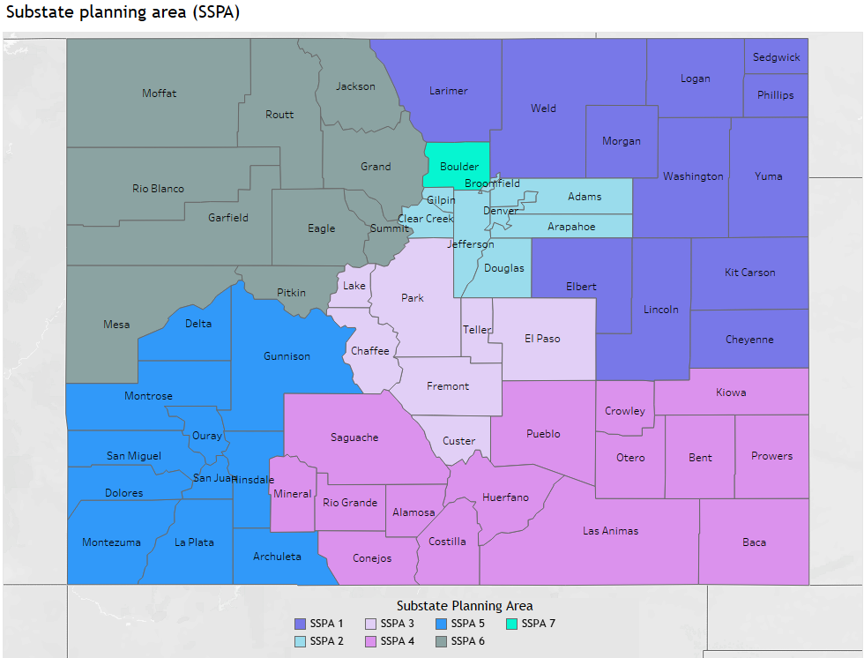
SSPA 1: NORTHEASTERN COLORADO
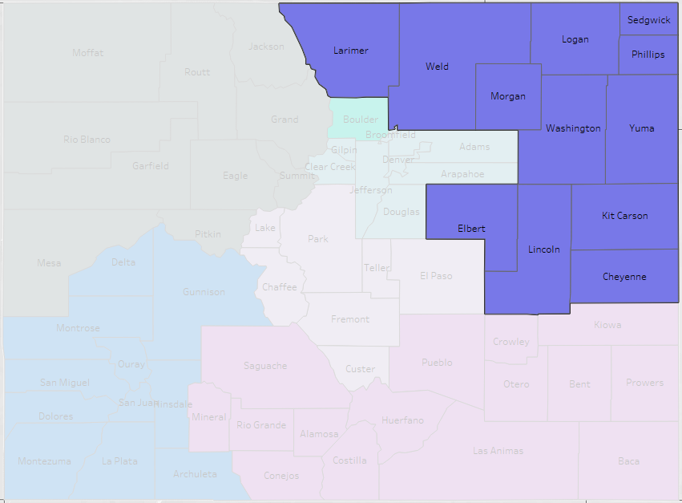
- Cheyenne
- Kit Carson
- Larimer
- Lincoln
- Logan
- Morgan
- Phillips
- Sedgwick
- Washington
- Weld
- Yuma

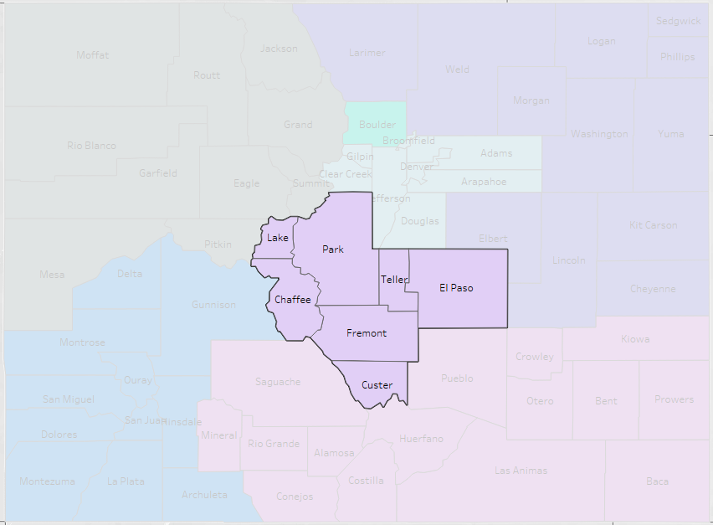
SSPA 3: COLORADO SPRINGS METRO AND SURROUNDING COUNTIES
- Chaffee
- Custer
- El Paso
- Fremont
- Lake
- Park
- Teller
SSPA 4: SOUTHEASTERN COLORADO & SAN LUIS VALLEY
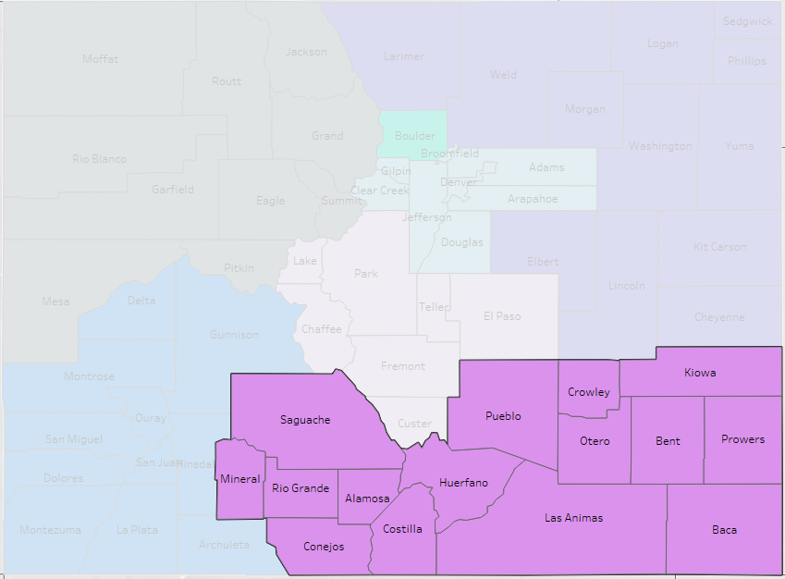
- Alamosa
- Baca
- Bent
- Conejos
- Costilla
- Crowley
- Huerfano
- Kiowa
- Las Animas
- Mineral
- Otero
- Prowers
- Pueblo
- Rio Grande
- Saguache

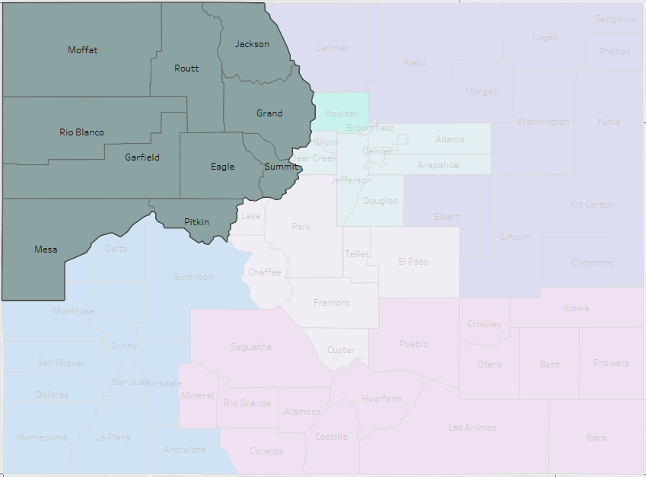
SSPA 6: North Western Slope

- Eagle
- Grand
- Garfield
- Jackson
- Mesa
- Moffatt
- Pitkin
- Rio Blanco
- Routt
- Summit

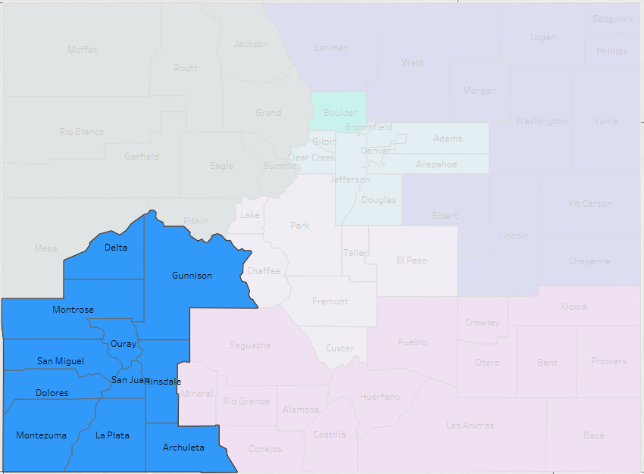
SSPA 5: South Western Slope

- Archuleta
- Delta
- Dolores
- Gunnison
- Hinsdale
- La Plata
- Montezuma
- Montrose
- Ouray
- San Miguel
- San Juan

Appendix B

FISCAL DOCUMENTATION

Applicants will find the Colorado Behavioral Health Administration capacity budget protocol documentation on Diversus Health Network website as one of the resources listed with this Grant Application, or use the following link: https://diversushealth.org/mso-resources/

Applicants will find the Colorado Behavioral Health Administration capacity budget template on Diversus Health Network website as one of the resources listed with this Grant Application, or use the following link: https://diversushealth.org/mso-resources/

Applicants may find the HCPF and BHA Behavioral Health Accounting and Auditing Guidelines on Diversus Health Network website as one of the resources listed with this Grant Application, or use the following link: https://diversushealth.org/mso-resources/

Appendix C

Credentialing

Diversus Health Network follows National Committee for Quality Assurance (NCQA) standards for credentialing of licensed independent practitioners. These standards require completion of a Colorado State Credentialing application, primary verification of licensure, and current professional liability insurance. The standards also require verification of claims history, either through an insurance carrier or via the National Practitioner Data Bank (NPDB), verification of licensure sanctions through the State Licensure Board or the NPDB, and a check for Medicare/Medicaid history through the Office of the Inspector General (OIG).

Substance Use treatment agencies licensed by the State of Colorado are also required to complete a Health Network Organizational application. Verification is performed for current professional liability insurance, claims history, license sanctions, active license for the level of care being provided, NPDB status, and OIG status.

The credentialing process is performed a minimum of every 36 months for all licensed/contracted providers.

Non-licensed entities are required to complete an Organizational Information application. In addition to the application, applicable verifications for OIG history and insurance will be collected.

All contractors are required to provide a Unique Entity ID, W9 form and a complteded to completed Electronic Funds Transfer (EFT) agreements for reimbursement. All contracts between Diversus Health Network and contractors will use the name on the provided W9 form or a Trade Name registered with the Colorado Secretary of State’s Office.

